EXPERIMENT-1

Kanban Board Experiment in Jira
Project: Food Delivery Applications
Name | M. Ramprasadh
Register No. | 192511355
Course Code | CSA1007
Date | 12 October 2026
Tool Used | Jira Software (Atlassian Cloud) – Kanban board template
Project Title | Food Delivery Application

1.Create a Kanban Board to Visualize the Tasks.
• Create Columns for To Do, In-Progress and Done.
• Add at least 5 Sample Tasks
• Move the Tasks across the Columns to Simulate the Workflow.

1. Aim
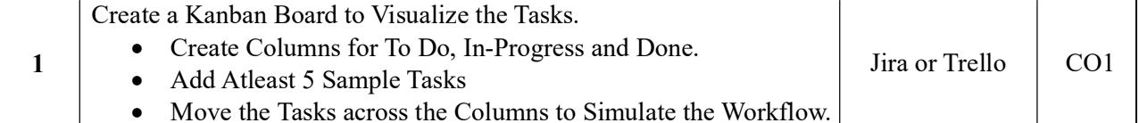

2. Tools Used
- Jira Software (Atlassian Cloud) – Kanban board template
- Web browser (Google Chrome)

3. Procedure
- Log in to Jira. Open the Atlassian Jira site in the browser and sign in with your account.
- Create a new project. Click Spaces (or Projects) in the left sidebar, choose Create space/project, and select the Kanban template (software development).
- Name the project. Enter the name “Food Delivery Applications” and the key “FD”, then click Create. Jira opens the project with an empty Kanban board.
- Open the Kanban board. In the project’s top navigation tabs, click Kanban board to view the board.
- Check the columns. Confirm that the board shows three columns: TO DO, IN PROGRESS and DONE. These are created by default and match the columns required for this experiment.
- Add sample tasks. Click + Create in the TO DO column (or the Create button at the top) and add six work items, entering a summary for each and clicking Create:
- FD-1 – Design Food Delivery App UI
- FD-2 – Create User Registration and Login
- FD-3 – Develop Restaurant Menu Page
- FD-4 – Implement Order Placement
- FD-5 – Implement Live Order Tracking
- FD-6 – Test Food Delivery Application
- Assign the tasks. Open each work item and set an assignee so that ownership is visible on the card (the assignee avatar appears at the bottom-right of the card).
- Start work on the first tasks. Drag FD-1 and FD-2 from TO DO into the IN PROGRESS column to show that work has begun on them.
- Complete tasks. Drag FD-4 and FD-6 through IN PROGRESS and drop them into the DONE column to show that they are finished.
- Leave the remaining tasks pending. FD-3 and FD-5 stay in TO DO, representing work that has not yet started.
- Verify the board. Check that each column shows the correct count: TO DO – 2, IN PROGRESS – 2, DONE – 2.
- Capture the screenshot. Take a screenshot of the final Kanban board and attach it to this document (see Section 5).

4. Workflow Simulation
All six tasks were created in the TO DO column. The table below shows the starting and final status of each task after moving them across the board.
Key | Task Name | Initial Status | Final Status
FD-1 | Design Food Delivery App UI | To Do | In Progress
FD-2 | Create User Registration and Login | To Do | In Progress
FD-3 | Develop Restaurant Menu Page | To Do | To Do
FD-4 | Implement Order Placement | To Do | Done
FD-5 | Implement Live Order Tracking | To Do | To Do
FD-6 | Test Food Delivery Application | To Do | Done

5. Output Screenshot
Final state of the Kanban board for the Food Delivery Applications project:
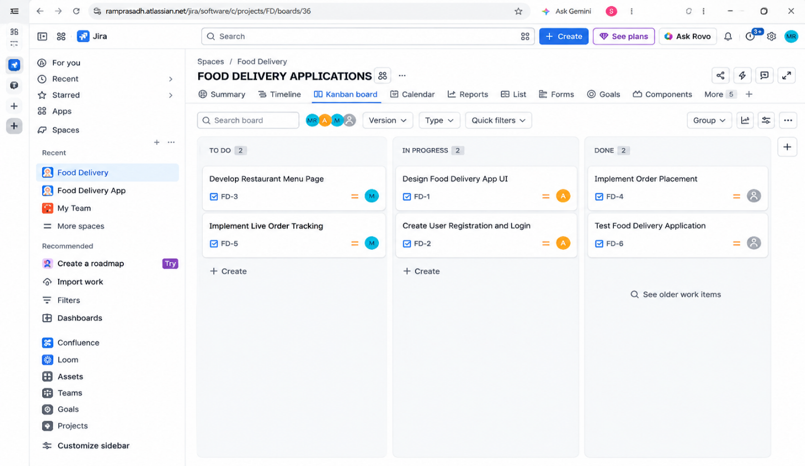
Figure 1: Jira Kanban board – Food Delivery Applications

6. Result
A Kanban board with three columns (To Do, In Progress and Done) was successfully created in Jira with six sample tasks. The tasks were moved between the columns to simulate a real workflow, with two tasks in each column in the final state.

7. Conclusion
The experiment shows how a Kanban board gives a clear, visual view of work in progress. Moving cards from To Do to In Progress to Done makes the status and ownership of each task easy to see and helps the team track progress.

